**CS 4400 Group Project**

**Cover Page**

**Phase II**

**Group #9**

1. Chris Halima
   1. Section: A with Professor Sweat
   2. Email: chalima3@gatech.edu
   3. T-Square Username: chalima3
2. Kara Pendley
3. Section: A with Professor Sweat

b. Email: klp244@gatech.edu

c. T-Square Username: kpendley6

1. Michelle Garcia
2. Section: B with Professor Simpkins

b. Email: [mgarcia46@gatech.edu](mailto:mgarcia46@gatech.edu)

c. T-Square Username: mgarcia46

1. Neil Barooah

a. Section: A with Professor Sweat

b. Email: [neilbarooah@gatech.edu](mailto:neilbarooah@gatech.edu)

c. T-Square Username: nbarooah3

**EER Diagram**

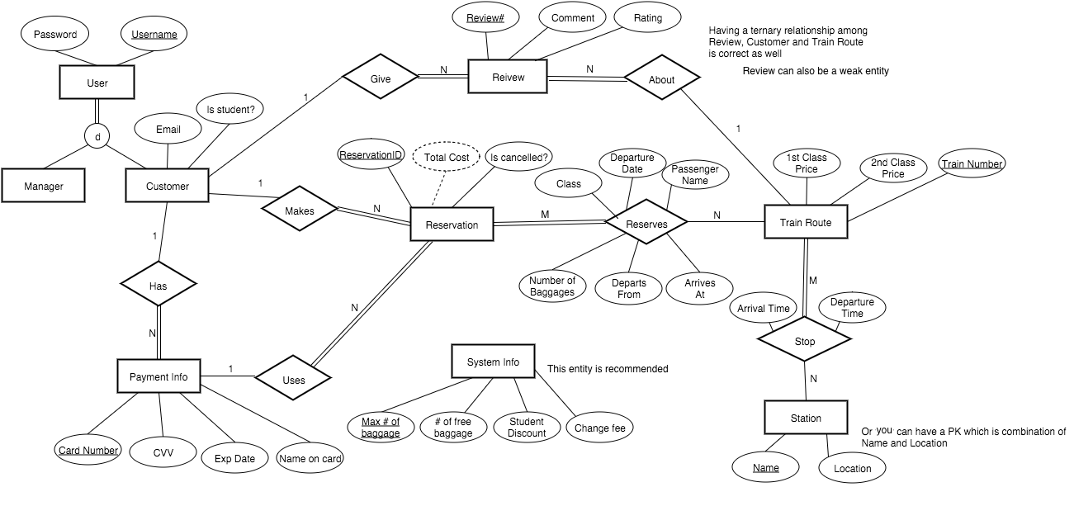

**Information Flow Diagram**

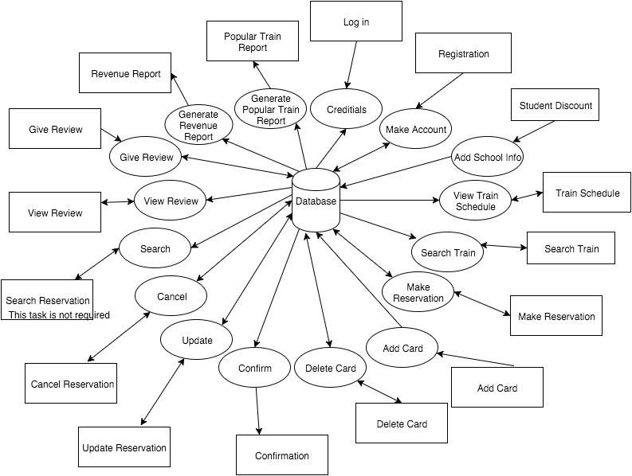

**Relational Schema for Group #9**

USER

|  |  |
| --- | --- |
| Username | Password |

MANAGER

|  |
| --- |
| Username |

CUSTOMER

|  |  |  |
| --- | --- | --- |
| Username | Email | Is_Student |

PAYMENT_INFO

|  |  |  |  |  |
| --- | --- | --- | --- | --- |
| Card_No | CVV | Exp_Date | Name_on_Card | C_Username |

REVIEW

|  |  |  |  |  |
| --- | --- | --- | --- | --- |
| Review_No | Comment | Rating | C_Username | Train_No |

RESERVATION

|  |  |  |  |
| --- | --- | --- | --- |
| Reservation_ID | Is_Canceled | Card_No | C_Username |

RESERVES

|  |  |  |  |  |  |  |  |
| --- | --- | --- | --- | --- | --- | --- | --- |
| Reservation_ID | Train_No | Class | Departure_Date | Passenger_Name | No_Bags | Departs_From | Arrives_At |

TRAIN_ROUTE

|  |  |  |
| --- | --- | --- |
| Train_No | First_Class_Price | Second_Class_Price |

STOP

|  |  |  |  |
| --- | --- | --- | --- |
| Train_No | S_Name | Arrival_Time | Departure_Time |

STATION

|  |  |
| --- | --- |
| Name | Location |

SYSTEM_INFO

|  |  |  |  |
| --- | --- | --- | --- |
| Max_No_Bags | No_Free_Bags | Student_Discount | Change_Fee |

**SQL Table Statements for Group #9**

**CREATE TABLE** USER

(Username VARCHAR(20) **NOT NULL,**

Password VARCHAR(20) **NOT NULL**,

**PRIMARY KEY** (Username) );

**CREATE TABLE** MANAGER

(Username VARCHAR(20) **NOT NULL,**

**PRIMARY KEY** (USERNAME),

**FOREIGN KEY** (Username) **REFERENCES** USER(Username)

**ON UPDATE** CASCADE);

**CREATE TABLE** CUSTOMER

(Username                    VARCHAR(20)                     **NOT NULL,**

Email                             VARCHAR(30)                     **NOT NULL,**

Is_Student                     BOOL,

**PRIMARY KEY**(Username),

**FOREIGN KEY** (Username) **REFERENCES** USER(Username)

**ON UPDATE** CASCADE,

**UNIQUE**(Email));

**CREATE TABLE** PAYMENT_INFO

(Card_Number INT **NOT NULL**,

CVV INT **NOT NULL**,

Exp_Date CHAR(5) **NOT NULL**,

Name_on_Card VARCHAR(50) **NOT NULL**,

C_Username VARCHAR(20) **NOT NULL**,

**PRIMARY KEY** (Card_Number),

**FOREIGN KEY** (C_Username) **REFERENCES** CUSTOMER(Username)

**ON UPDATE** CASCADE);

**CREATE TABLE** TRAIN_ROUTE

(Train_Number   INT            **NOT NULL,**

1st_Class_Price   DECIMAL(5,2)            **NOT NULL,**

2nd_Class_Price   DECIMAL(4,2)            **NOT NULL,**

**PRIMARY KEY** (Train_Number) );

**CREATE TABLE** REVIEW

(Review_No  INT **NOT NULL,**

Comment  VARCHAR(400),

Rating  INT **NOT NULL,**

C_Username  VARCHAR(20) **NOT NULL,**

Train_Number  INT **NOT NULL,**

**PRIMARY KEY**(Review_No),

**FOREIGN KEY** (C_Username) **REFERENCES** CUSTOMER(Username)

**ON UPDATE** CASCADE,

**FOREIGN KEY** (Train_Number) **REFERENCES** TRAIN_ROUTE(Train_Number)

**ON UPDATE** CASCADE);

**CREATE TABLE** RESERVATION

(Reservation_ID             INT                                      **NOT NULL,**

Is_Cancelled                  BOOL                                  **NOT NULL,**

Card_Number                INT                                      **,**

C_Username                 VARCHAR(20)                     **NOT NULL,**

**PRIMARY KEY** (Reservation_ID),

**FOREIGN KEY** (Card_Number) **REFERENCES** PAYMENT_INFO (Card_Number)

**ON DELETE** SET NULL **ON UPDATE** CASCADE,

**FOREIGN KEY** (C_Username) **REFERENCES** CUSTOMER (Username)

**ON UPDATE** CASCADE);

**We will only allow them to delete the card after the reservation is complete (using the UI), but after that, it will be set to null when deleted

**CREATE TABLE** RESERVES

(Reservation_ID            INT                                      **NOT NULL,**

Train_Number               INT                                      **NOT NULL,**

Class                             INT                                      **NOT NULL,**

Departure_Date            DATE                                   **NOT NULL,**

Passenger_Name         VARCHAR(50)                    **NOT NULL,**

No_Bags                       INT                                      **NOT NULL,**

Departs_From               VARCHAR(50)                    **NOT NULL,**

Arrives_At                      VARCHAR(50)                    **NOT NULL,**

**PRIMARY KEY** (Reservation_ID),

**FOREIGN KEY** (Train_Number) **REFERENCES** TRAIN_ROUTE (Train_Number)

**ON UPDATE** CASCADE);

**CREATE TABLE** STATION

(Name VARCHAR(50) **NOT NULL**,

Location VARCHAR(50) **NOT NULL**,

**PRIMARY KEY** (Name) );

**CREATE TABLE** STOP

(Train_Number INT **NOT NULL**,

S_Name VARCHAR(50) **NOT NULL,**

Arrival_Time TIME **NOT NULL**,

Departure_Time TIME **NOT NULL**,

**PRIMARY KEY** (Train_Number, S_Name),

**FOREIGN KEY** (Train_Number) **REFERENCES** TRAIN_ROUTE(Train_Number)

**ON UPDATE** CASCADE,

**FOREIGN KEY** (S_Name) **REFERENCES** STATION(Name)

**ON UPDATE** CASCADE);

**CREATE TABLE** SYSTEM_INFO

(Max_No_Bags INT **NOT NULL,**

No_Free_Bags INT **NOT NULL,**

Student_Discount DECIMAL(2,2) **NOT NULL,**

Change_Fee DECIMAL(4,2) **NOT NULL,**

**PRIMARY KEY**(Max_No_Bags) );